Arctic Graphs
Units, millions of km²
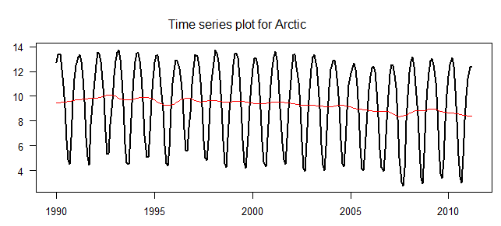
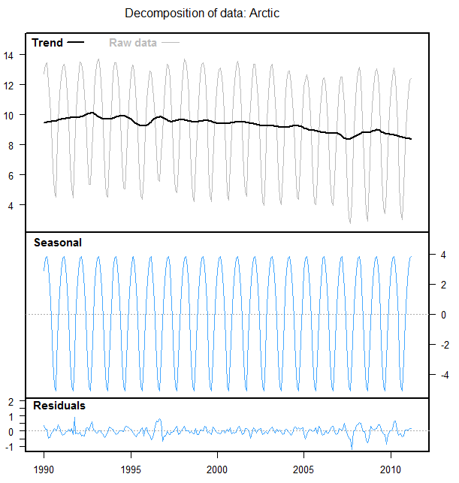
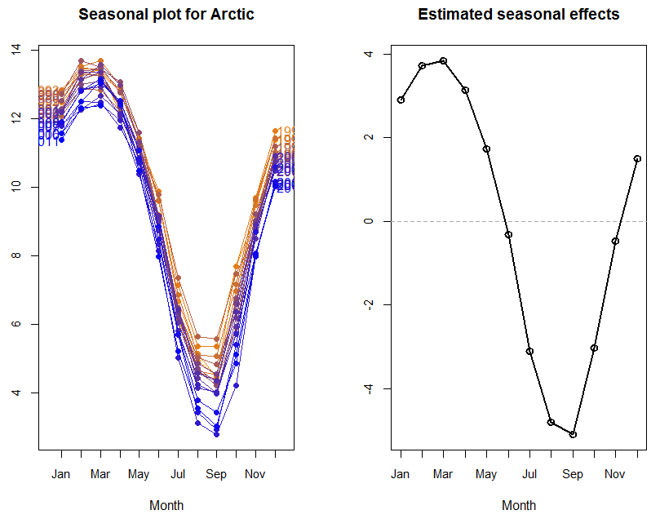
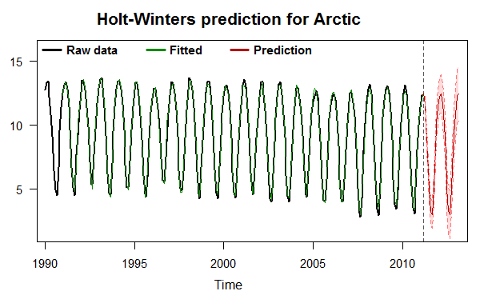
fitted lower 95% bound upper 95% bound
Apr 2011 11.644755 11.059483 12.230027
May 2011 10.007984 9.298109 10.717860
Jun 2011 7.768086 6.951344 8.584828
Jul 2011 4.985253 4.073120 5.897386
Aug 2011 3.247304 2.247959 4.246649
Sep 2011 2.974021 1.893656 4.054385
Oct 2011 5.042567 3.886069 6.199065
Nov 2011 8.161452 6.932794 9.390111
Dec 2011 10.132259 8.834747 11.429772
Jan 2012 11.461963 10.098399 12.825527
Feb 2012 12.268707 10.841501 13.695914
Mar 2012 12.423776 10.935025 13.912527
Apr 2012 11.662464 10.068950 13.255978
May 2012 10.025693 8.375699 11.675687
Jun 2012 7.785795 6.080640 9.490950
Jul 2012 5.002962 3.243837 6.762086
Aug 2012 3.265012 1.453002 5.077023
Sep 2012 2.991729 1.127821 4.855638
Oct 2012 5.060276 3.145375 6.975177
Nov 2012 8.179161 6.214100 10.144222
Dec 2012 10.149968 8.135514 12.164421
Jan 2013 11.479672 9.416536 13.542807
Feb 2013 12.286416 10.175258 14.397574
Mar 2013 12.441485 10.282917 14.600053
