(if x = number of small parcels, y = number of medium parcels, z = number of large parcels)

x = 26

y = 8

z = 6

So **26 small parcels, 8 medium parcels and 6 large parcels** were delivered.

Form the system of the equations

x + y + z = 40

14x + 22y + 40z = 780

z = 2y – 10

1)

2)

a=6, b=32, c=12

From the given equation

**6 people** paid the Grabaseat fare.

Form the system of equations

46x + 39y + 249z = 824903

44x + 44y + 244z = 751960

26x + 36y + 242z = 620142

(if x=cost of a Business premier ticket, y=cost of a Premium economy ticket, z=cost of an Economy ticket)

x = 5894

y = 2839

z = 1507

So **the cost of Business premier ticket is $5894, the cost of a Premium economy ticket is $2839,and the cost of a Economy ticket was $1507**

3)

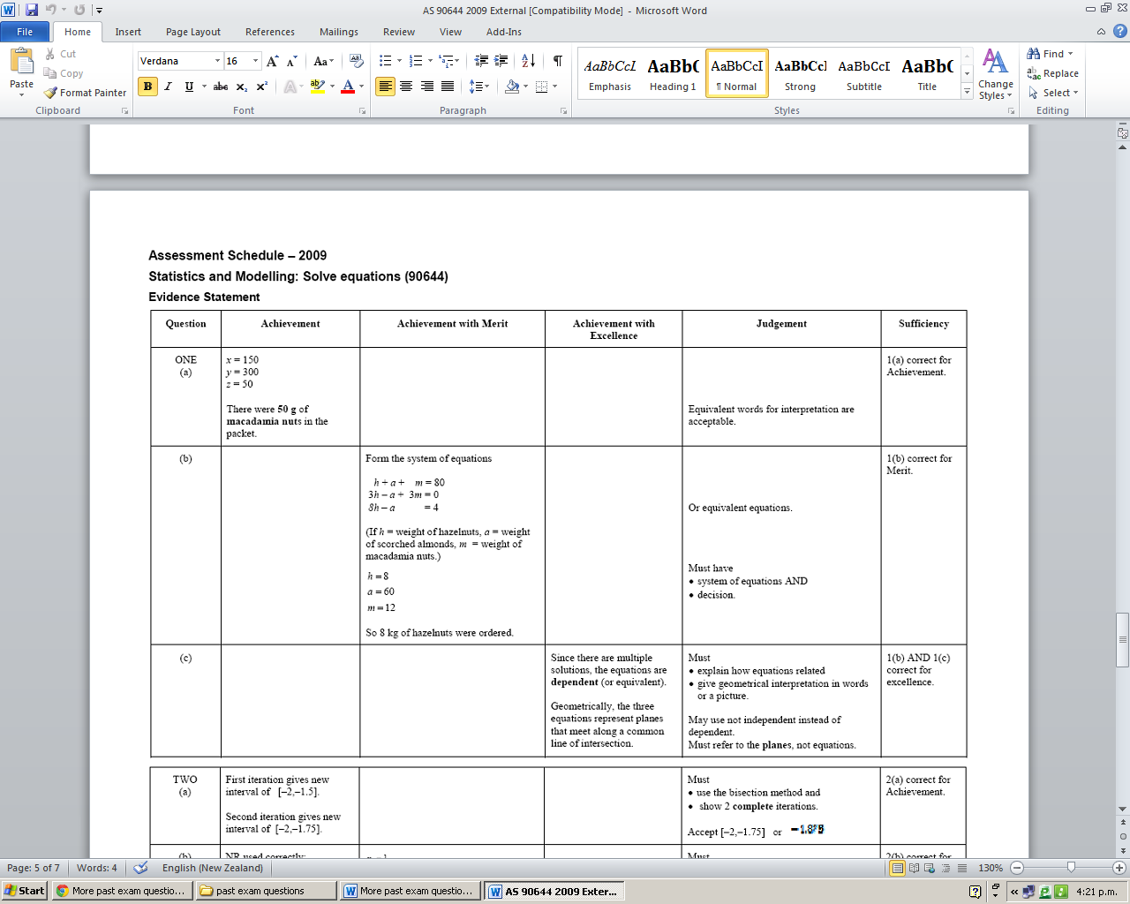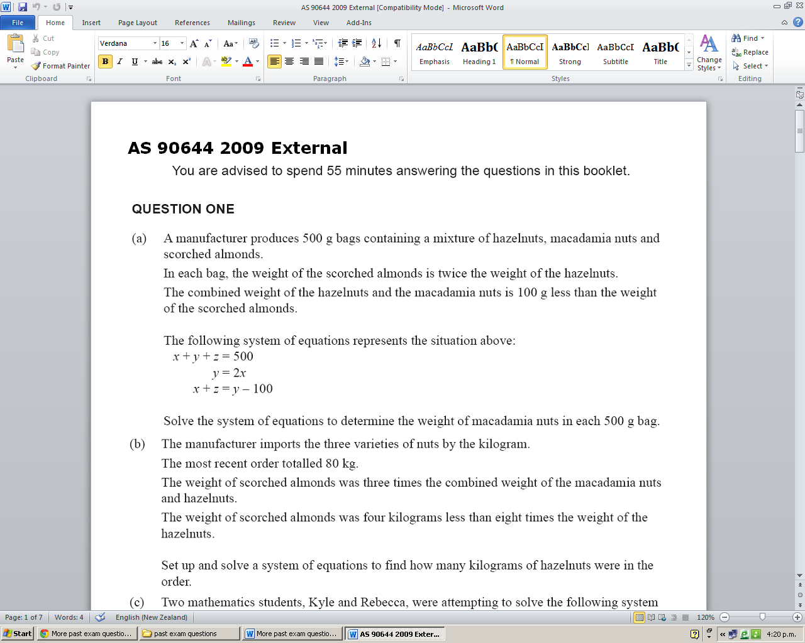

4)



5)

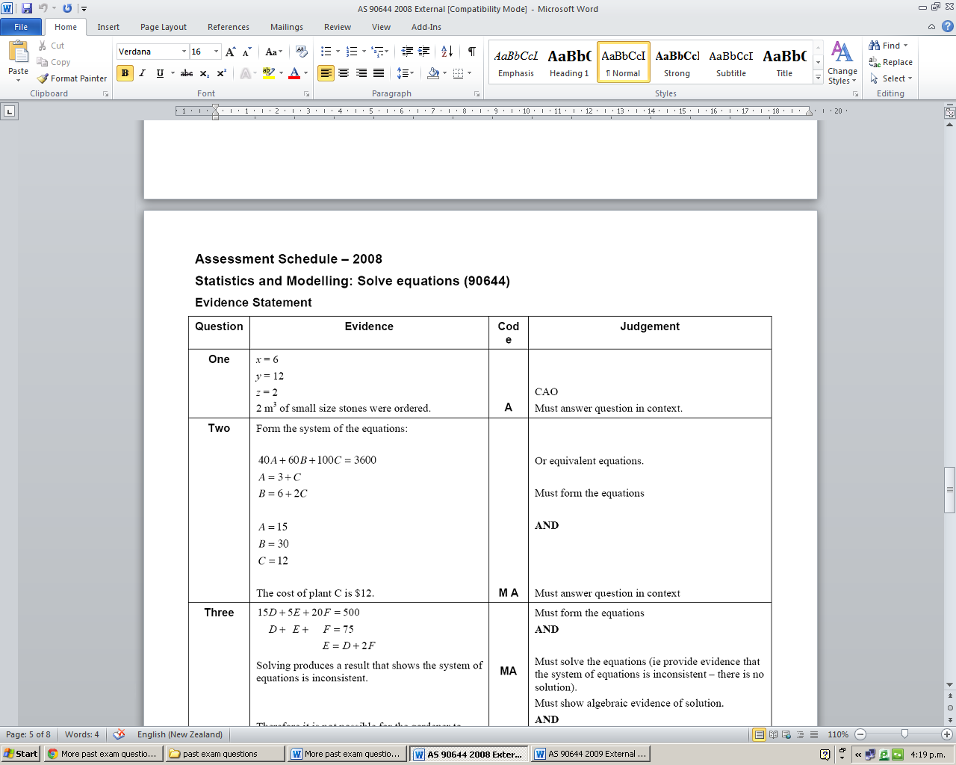

6)

$$3B+5P+2C=42.50$$

$$5B+2P+4C=60.50$$

$$2C+P=B+0.50$$

B= $8.50, P=$2, C=$3.50

7)