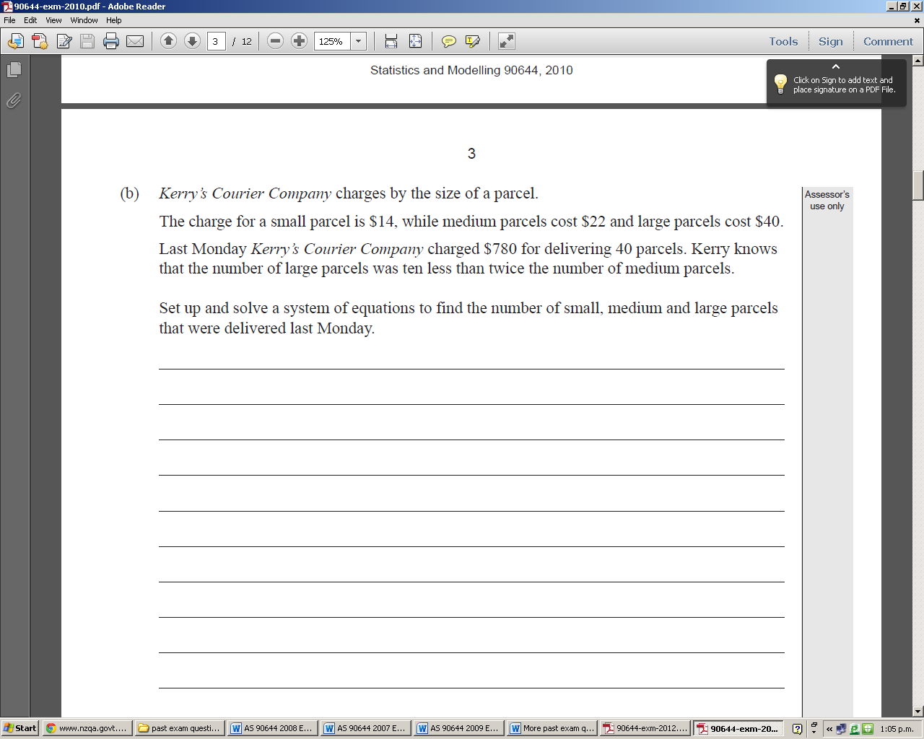

1)

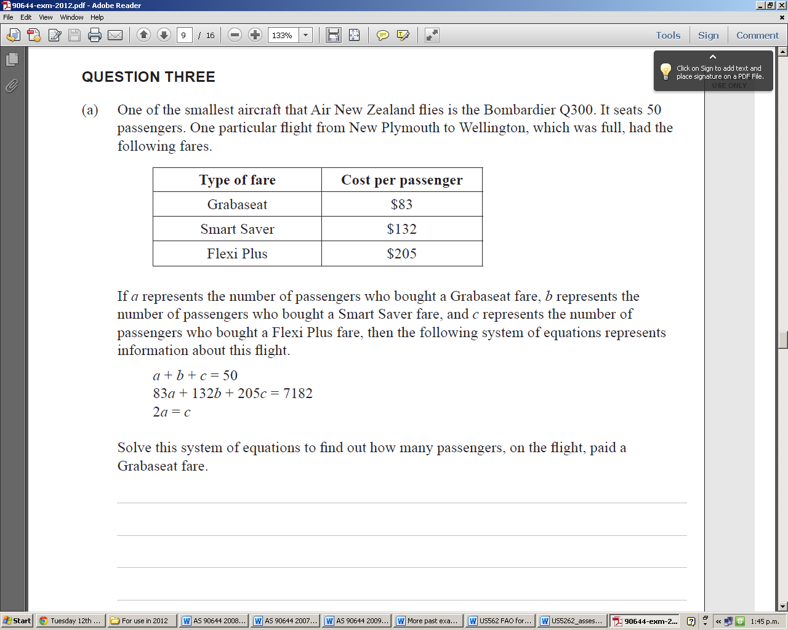

2)

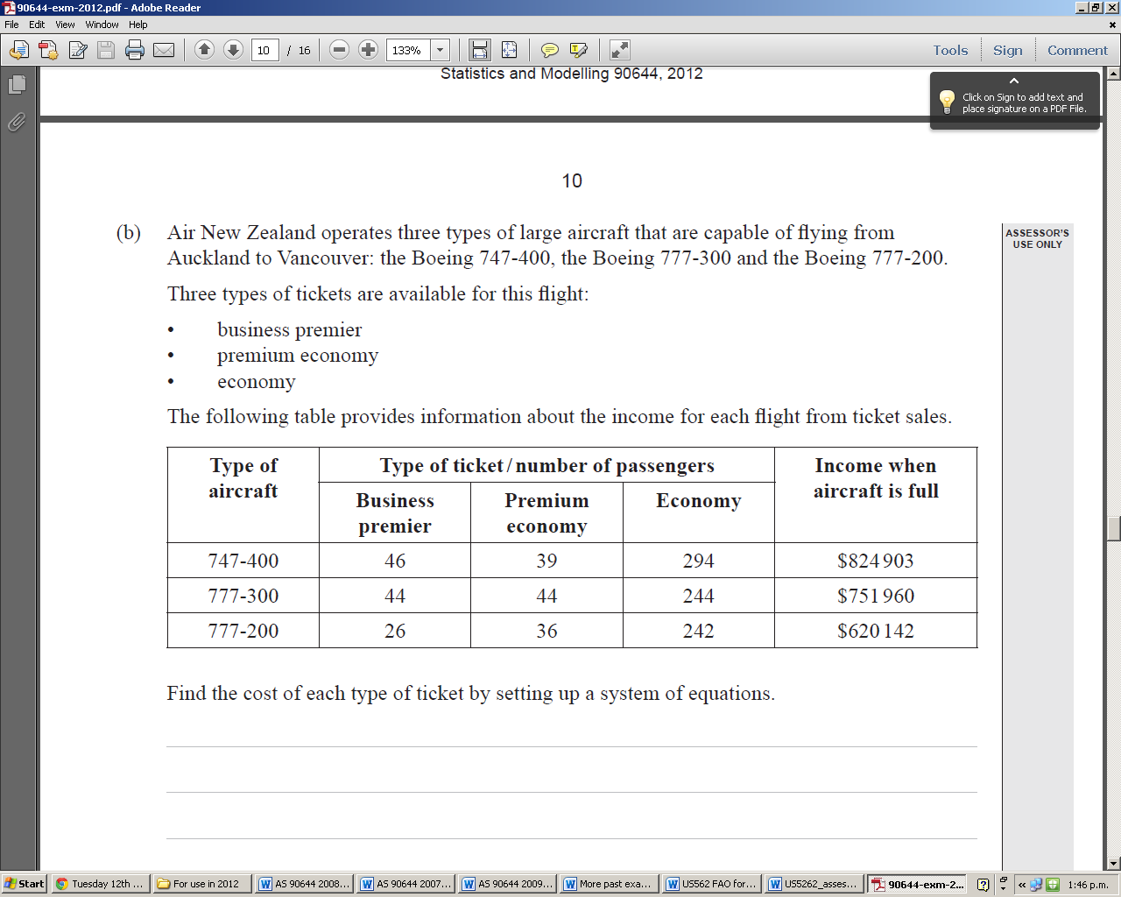

3)

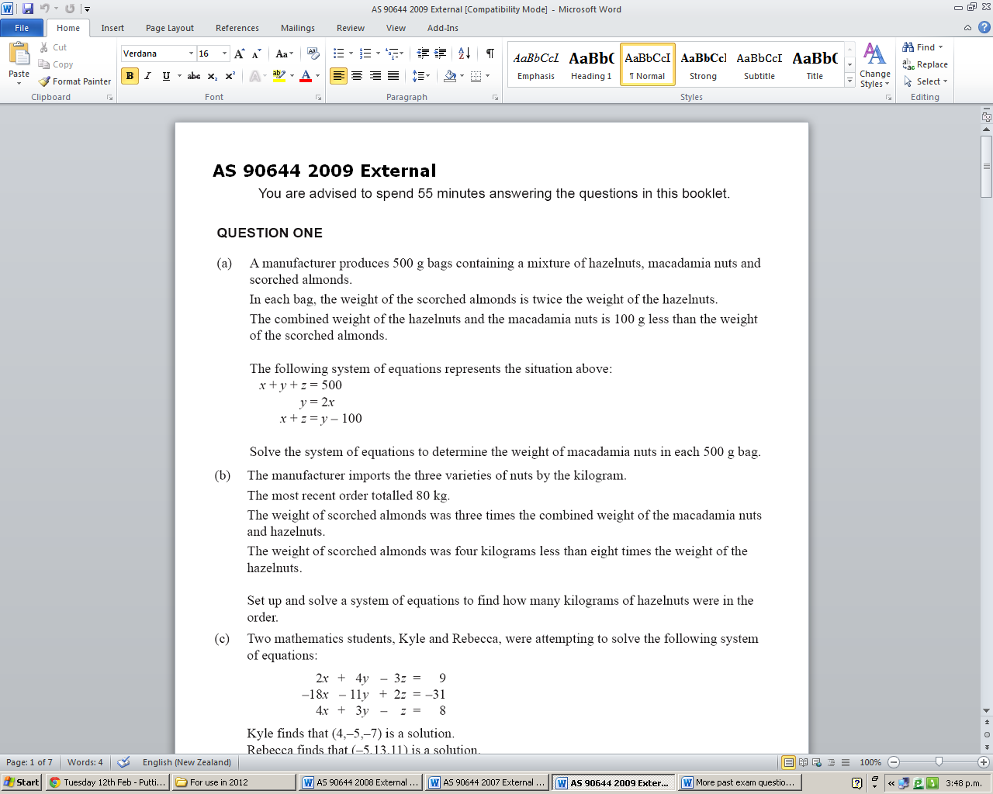

4)

Set up and solve simultaneous equations to determine the weight of macadamia nuts in each 500g bag.

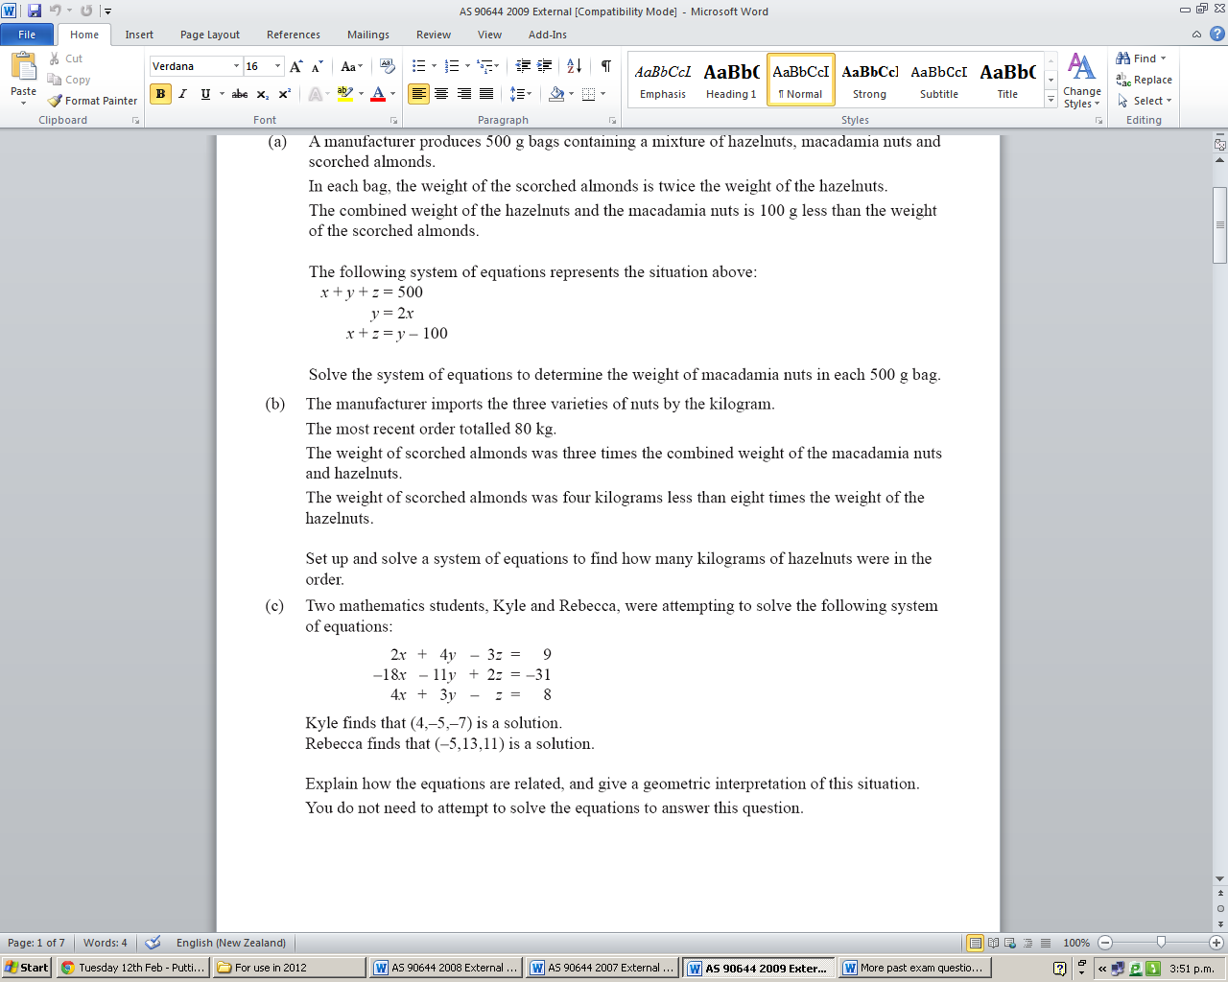

5)

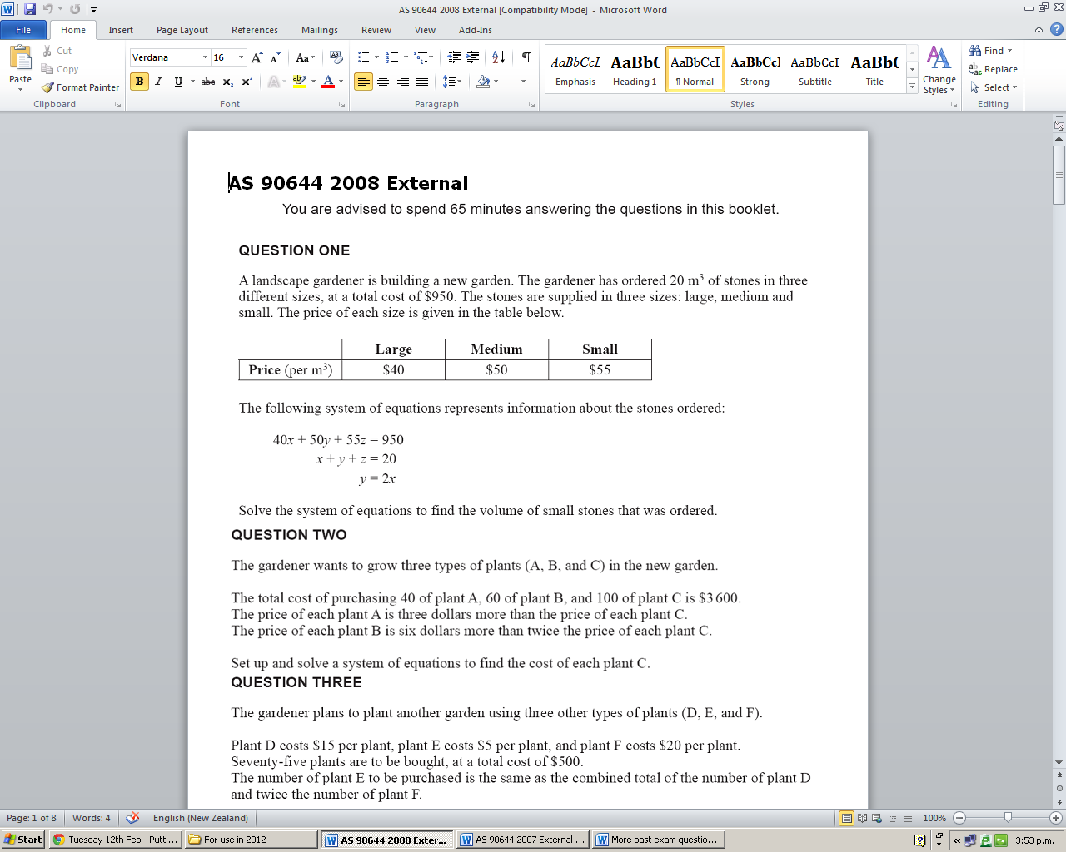

6)

7)

Two families went to the local KFC. One family ordered 3 burgers, 5 pieces of chicken and 2 chips and it cost them $42.50. The second family ordered 5 burgers, 2 pieces of chicken and 4 chips and it cost them $60.50. The cost of 2 chips and one piece of chicken is 50 cents more than the cost of 1 burger.

Set up and solve a system of simultaneous equations to find out the price of each item.